About the Project:-
- Heart Disease Prediction:-
- About Data:-
I collected the dataset from Kaggle , it’s a simple project just as a part of my Multiple Disease Prediction system , it has 1025 rows and 14 columns where the continous variables are Age(29-77) , trestbps(resting blood pressure (in mm Hg on admission to the hospital)) , chol ( cholestrol in mg/dl) , fbs(fasting blood sugar &gt; 120 mg/dl) (1 = true; 0 = false) , restecg(resting electrocardiographic results) , thalach(maximum heart rate achieved) , exang(exercise induced angina (1 = yes; 0 = no), oldpeak(ST depression induced by exercise relative to rest) , slope(the slope of the peak exercise ST segment) , ca(number of major vessels (0-3) colored by flourosopy), thal (thal: 0 = normal; 1 = fixed defect; 2 = reversable defect),there is no class imbalance(1- 526 , 0-499)
- What I did preprocessing :-
Checked for Missing values , it don’t have any missing values . then made a custom function for outlier detection using the IQR method and found out there are no outliers in the dataset
- EDA and insights :-

Perfomed EDA in form of KDEplot and found out Age and trestbps are almost normal while chol is slightly right skewed and thalach is bit left skewed , oldpeak is right skewed , then did correlation matrix and found no such significant correlation(>0.5)

- Testing and Model Fitting :-

Performed train_test split and looked for multicollienarity in data through Vif , didn’t find any significant vif(>5) , since I want to apply logistic regression I checked the assumption of linearity between log-odds and independent variables , so I fitted a base LR model with numerical features and found out log-odds and made plot of Logit vs all numeric variables and seem to find out chol didn’t assume the linearity property by seeing the plot so I applied sqrt , power , boxcox and log transform but still couldn’t make it linear so I discretized it using quantiles and used one hot encoding because binning lets the model estimate a separate effect per bin instead of trying to fit a line,its best suitedwhen the plot is eraatic a in my case,then I used cooks’s distance to check for any influentials points and found out 84 points but after invetigating those rows seemed genuine and we continued with out same model , but binning lead to a accuracy drop then out baseline LR so I used polyfeatures of degree 3 , which seemed to somewhat capture the non linear nature of the feature and provided a much better test accuracy of 94% with a similar F1 score , auc score 93%

- Constructed a function which can take any model , make prediction and give test accuracy,precision,recall,f1 with classification report and auc-roc curve
- Used KNN,SVM,DT,Rf,Gradient Boosting , the highest accuacy was achieved by Decision tree about 97% and with hyperparameter tuning of criterion,max_depth,min_Sample_split,min_sample_leaf,splitter achieved a 99% accuracy , tried the other models also and rf was also giving around 96% but since a simple model is providing a good accuracy, why should we go towards more complex like boosting and bagging techniques . dt was also easily interpretable. Stored the DT model as a pickel file for deplyment
(Just say it like this but if they ask did u apply outlier and missing value just say yes i first spilitted data in train test then applied all this )

2 . Diabetes Prediction :-

  - About Data :-
Dataset from Kaggle , shape (2000,9) , features :- ['Pregnancies', 'Glucose', 'BloodPressure', 'SkinThickness', 'Insulin',
'BMI', 'DiabetesPedigreeFunction', 'Age', 'Outcome'],
dtype='object') , imbalanced data (not diabetes constitute 65% ,35% diabetes)
20-30 age group is highest in our data while the min age is 21 and max age is 81
  - EDA and feature engineering:-
    - We drew the kde plot of all the features and found out pregnancies is positively skewed , glucose and bp seems quite normal , skinthickness is bimodal , insulin is right skewed , BMI is almost symmetric , age and diabetespedifreefunc is right skewed
    - Then we compared the mean values of all features with the outcome feature , for pregancies,glucose,BP,skinthickness,insulin,bmi,diabetes pedigree , age have higher mean for disease(1) but BP
    - Plotted a heatmap and only age and pregnancy seems to have a strong correlation (greater than 0.5) while others are between -0.45-0.45
    - Upon analyzing the data more , we observe a lot of 0 values in multiple features which is generally considered as NaN in medical data, then i checked which rows have all nan values but there were none so I coverted those 0 values to nan
    - Then I used msno library to see the matrix of missing values , heatmap and dendogram of missing values , all this plots hinted towards that missing values are not MCAR , but MAR, also I used Little’s MCAR test which I created from scratch and it proved me the result statistically that its not MCAR so I used MICE method of imputation.
    - Then I just created the pairplot to see the density plots of all the feature based on outcome
    - Then created a custom function to check for outliers and found out there were 69 ,68 outliers in Insulin and Diabetespedigreefunction and other features has less no of outliers , glucose didn’t have any outlier
    - Now in medical data , sometimes outlier points are not always error points but its possible but rare , so upon examining except Insulin all the outliers are relevant just they are rare but insulin has some extreme high and low valeus which is not generally possible
    - So I used quantile capping for Insulin instead of IQR capping since insulin is highly positive skewed and quantile capping is better when dealing with highly skewed features
    - Then since all the other features are meaningful but rare so used LOF to find the outlier , plotted a plot between n_neighbors and mean negative outlier factor to understand which n_neighbor value to take for Lof , we observe at 10 there is a constant line so it tells above 10 its not improving , hence we take neighbor as 10
    - Before applying lof we used robust scaler to reduce the influence of existing outliers when calculating distances — this gives more reliable LOF scores.
    - So after lof there were still some outlier left in BMI and other features but those were meaningful and not much important to remove but still I converted the bmi into 5 categoreis based on bmi values which are Underweight,normal,overweifht,obesity1,obesity2 and 3
    - Changed insulin to normal and abnormal category and glucose to 4 categoreis which are low , normal , overweight ,secret
    - Converted those cat features to dummies using OHE and applied final robust scaler to only the numeric features for model fitting
    - Then appied smote because of class imbalance
    - Used feature selection using filter methods like Forwardselection , backward and recursive feature elimination and then used a ensemble based feature selection combining and normalizing the scores of various methods like mutual information,random forest feature importance,permutation importance,RFE,SFS,logistic with l1(lasso) , shap scores then ran 2 models logistic and rf for different set of features like 5,7,8,12,15 with their R2 and adjusted r2 in table , found out 8 features gave the best combination of r2 and adjusted r2 by both the models(took the avg by both models) . the features are [Glucose, NewGlucose_Normal, BMI, Age, DiabetesPedigreeFunction, NewBMI_Underweight, NewGlucose_Secret, Pregnancies].
    - Then plotted a shap plots like beeswirm plot ,barplot , and force plots, go through the notebook once ( I explained every plot clearly there witht the insights,its better if we see the plots )
( Say whatever missing value tratement , outlier detection u did is after train test split , did on train and used it to do for same test also )
(Outliers shall never be removed from test , it should only be removed from training data . I used LOF to remove the outlier from training only , test is untouched )
(Missing values imputation shall be done on both train and test and scaling also after train test like Standard scaler use fit_trasnform on training and just trasnform on test)
(Class imbalance techniques should also be used on X_train and y_train only , • Handle missing values, scaling, encoding → then apply SMOTE.
• Because SMOTE works in feature space → it needs proper numeric representations.)

  - Model Fitting and Evaluation:-
    - Fitted logistic regression an first checked for multicollinearity using vif but coulnt find any and then checked the assumption of linearity b/w logodds and numeric features, some feature slike BP,skinthickness,insulin,age were non-linear so applied box-cox,sqrt,log ,power transform but couldn’t make them linear so used a poly feature of degree 2 and 3 which resulted in a decent acc and f1 score of around 78% acc and 75% f1
    - Then used tree based model to capture better non-linearity like dt,rf,bosoting like gradboost,xgboost and lightbgm . ran a optuna searcg to select the best model with best hyperparameter , it found out lightbgm with hyperparameters and gave the best result of 96% acc and 94% f1 score
    - Then applied a stacking and voting classifier , voting classifier worked the best with lightbgm_optuna and rf giving a 98.5% accuracy and 96% f1 score .
3. Brain Tumor Prediction :-
  - About Data:-
I got the data from kaggle , it has 4 categories say 4 directories of glioma , meningioma,no tumor , pituitary where the tesing data contain 1300 images and training data contains 1311 and training data contains 5712 images
  - Steps used:
Took image size of (150,150) , batch size 32 , used image data generator with data augmentation of rotation , zoom,width_shift , height_shift , horizontal_flip , validation_split of 20% , like this I made train_datagen,test_Datagen and then used flow_from_directory to load the images in train,test and validation generator variables with the given target and batch size , made a countplot of categories in training data.
  - Used a custom CNN model with 4 conv layer each followed with a batchnormalization layer and then a max pooling layer,atlast used a flatten layer and added a fully connected nn with 256 neurons, used relu activation in all conv layers and padding=same , after the fully connected nn , used dropout of 0.5 then the output layer with neurons = length of class labels which is 4 with a activation func of Softmax . Compiled with metrics accuracy and loss as categorical cross entropy since it’s a multiclass problem. And optimizer as adam.
  - Also introduced callbacks such as Earlystopping and ReducedLRonplateau which monitor the val_loss , with the custom model received test accuracy of 82% and 81% f1 score
  - Then plotted images side by side with their true disease category label and predicted category label
  - Used transfer learning to train the preuilt inceptionV3 model with the imagenet weights and we did not include the fully connected layer of the inceptionv3 . Now instead of flatten layer I used globalaveragepooling as it reduced overfitting and works better with pre-trained models, then added a fully connected layer with 4096 neurons and relu activation functions and at end included the output layer with 4 neurons and activation as softmax, • Freezes the base InceptionV3 layers so their pre-trained weights aren't updated during training.Only the newly added Dense layers will learn. Used the same optimizer and loss with a test accuracy of 85%
  - Similarly used the VGG19 , with the same structure and achieved 88% acc
  - Then used a resent152 and got 92% acc and then tried fine tuning it , the fine tuning is done as follows :-
- Loads a pre-trained ResNet152V2 model without the classification layer (include_top=False).
- Freezes all layers so their weights don’t get updated during initial training.
- Unfreezes last 30 layers of the base model to allow fine-tuning.
• Global Average Pooling converts 2D features to 1D.
• Dense layers serve as the classifier:
- 4096 neurons with ReLU to learn complex patterns.
- Final Dense layer with softmax for multiclass classification.
Witth this achieved a 96.5% accuracy and 93% F1 score

- Oct Scan Eye Disease Prediction :-
  - Dataset collected from kaggle having 4 categories CNV,DME,DRUSENNORMAL where training data contains 67k images , validation data contains 16700 data and test data contains around 1k images .
Used callbacks like earlystopping and checkpoint for all the models. (not much class imbalance)
  - Built a custom cnn model(image augmentation also done) with 7 conv layers where each layer has maxpoling and every even conv layer has a dropout of 0.2 and at end we have globalpooling layer and a output layer with 4 neurons as 4 class labels received an test accuracy of 96%
  - Then used vgg16 model by disabling the fully connected layer , used flatten and then added 3 hidden layers as fully connected nn each with batch normalization and dropouts . weights are chosen as imagenet,got a test acc of 90%
  - Then used resent50 with only one dropout and then a output layer of 4 neurons received accuracy of 96.2%
  - Then applied densenet1221 with the similar structure of resnet and received accuracy of 98.5%
  - All models are applied with image augmentation

- Brain Tumor Segmentation:-
1. Got data from kaggle , used Unet got 98% test acc 85% dice score, 83% iou score
2. then created a plot showing original image , masked image and predicted mask side by side, img size (256,256)

Questions from CNN :-
  - Why CNN is used , why ann cant be used in images ?
Ans :- Why ANNs Don’t Work Well for Images
1. Too Many Parameters
Imagine a grayscale image of size 100×100 pixels:
- That’s 10,000 input features.
- If you connect this to a dense layer with just 100 neurons, you need:
10,000×100=1,000,000 weights!
🔴 Problem: Huge memory and computation cost. It quickly becomes unmanageable for larger images like 224×224×3.

2. No Spatial Awareness
- ANNs treat all pixels independently.
- They don't know that a group of pixels close together may represent a shape (like an edge, curve, eye, etc.).
🔴 Problem: ANNs ignore the 2D structure of images.

3. No Translation Invariance
- If an object moves slightly in the image (e.g. a dog moves from center to corner), ANNs may fail to recognize it.
🔴 Problem: ANNs are not position-invariant — they learn patterns based on absolute pixel positions.
What this means actually?
Ans :- • ANNs (Artificial Neural Networks) use fully connected layers.
• That means every input pixel is connected to every neuron in the next layer.
• The position of every pixel is treated as fixed.
• If you shift the dog in the image slightly (e.g., move it from center to left), the entire pattern of pixel values changes — even though it's the same dog.
What CNNs Do Differently:
- CNNs use convolutional filters that slide across the image.
- These filters look for patterns (like edges, eyes, fur) regardless of where they appear.
- So even if the dog shifts position, the same filter can still detect its shape or features.
This gives CNNs a property called:
✨ Translation Invariance
CNNs can still recognize objects even if they move slightly in the image.

✅ Why CNNs (Convolutional Neural Networks) Work Better
1. Local Pattern Detection
- CNNs use filters/kernels that look at small patches (like 3×3 or 5×5).
- They detect edges, textures, corners, etc., locally.
🟢 Advantage: They extract spatial features and build hierarchical representations.

2. Parameter Sharing
- A 3×3 filter has only 9 weights, and it slides over the entire image.
- Same weights are reused.
🟢 Advantage: Far fewer parameters, so model is faster and less prone to overfitting.

3. Translation Invariance
- CNNs can still detect a feature regardless of where it appears in the image.
- Pooling layers help make the model robust to shifts and distortions.
🟢 Advantage: CNNs generalize better to variations in input images.
  - So can we use RNN and LSTM for images ?
Ans :- Why RNNs (and LSTMs) aren’t ideal for image classification
- Images are spatial, not temporal or sequential in nature.
  - RNNs process sequences, one step at a time.
  - But an image is a 2D grid of pixels — not a 1D time sequence.
- Computationally inefficient for images.
  - You’d need to flatten the image or feed it row by row or pixel by pixel into an RNN.
  - This is very slow and doesn't leverage spatial locality like CNNs.
- Lack of spatial pattern extraction.
  - RNNs don’t have convolutional filters.
  - They don’t detect edges, shapes, or textures well.
3. Which CNN architecture did you use and why?
✅ Sample Answer:
I used [ResNet50 / InceptionV3 / VGG16 / custom CNN] for transfer learning. I chose this because it's pretrained on ImageNet and already captures rich visual features, which helps reduce training time and improves accuracy on medical imaging tasks.
4. How did you evaluate your model’s performance?
✅ Sample Answer:
I used metrics like accuracy, precision, recall, and F1-score, particularly focusing on recall because in medical diagnostics, false negatives (i.e., undetected tumors) are more dangerous than false positives.
5. What preprocessing steps did you apply?
✅ Sample Answer:
- Resizing images to a fixed input size (e.g., 224×224)
- Augmentation: flipping, rotation, zoom to improve generalization
6. What are some risks in deploying this model?
✅ Sample Answer:
- Bias due to unbalanced or poor-quality data
- Overfitting to a specific scanner type or institution
- Lack of generalizability to new patient populations
- Ethical concerns like misdiagnosis and lack of interpretability
7 . What can you improve in your current model?
✅ Sample Answer:
- Fine-tune the base model rather than just using frozen features
- Add ensemble methods or attention modules
- Try using 3D CNNs if working with volumetric MRI scans
- Incorporate clinical metadata (e.g., age, symptoms) for multimodal learning

8. Would you prefer high precision or high recall in this task?
- ✅ Sample Answer:
- I would prefer high recall because missing a tumor (false negative) can lead to severe consequences. It’s better to flag a suspicious image and then let a radiologist confirm, even if it includes false positives.

9. How do you explain the model’s decisions (interpretability)?
✅ Sample Answer:
I used Grad-CAM to generate heatmaps over the MRI scans to visualize where the CNN was focusing. This helps ensure the model is attending to relevant tumor regions, increasing trust in medical use cases.

- How CAM , Grad-cam and grad-cam +++ differs:-

What is CAM (Class Activation Mapping)?
CAM is a technique to visualize the regions in an image that are important for a CNN's prediction — especially for image classification tasks.
It generates a heatmap over the image, showing which areas most influenced the model’s decision for a particular class (e.g., tumor vs. no tumor).

🧠 How CAM Works – Step by Step
CAM is only applicable to CNNs with a specific architecture — where:
- The last convolutional layer is followed by
- A Global Average Pooling (GAP) layer, and then
- A fully connected (dense) layer that outputs class scores.
Visual Example Flow (for brain tumor classification)
- Image passes through the CNN.
- Final conv layer outputs spatial features (e.g., shape of 7×7×512).
- GAP averages each feature map to a scalar → shape becomes (1×512).
- Dense layer computes class logits using these 512 scalars.
- CAM combines the original 7×7×512 feature maps with the weights to produce a 7×7 heatmap.
- Resize heatmap to match original image size and overlay.

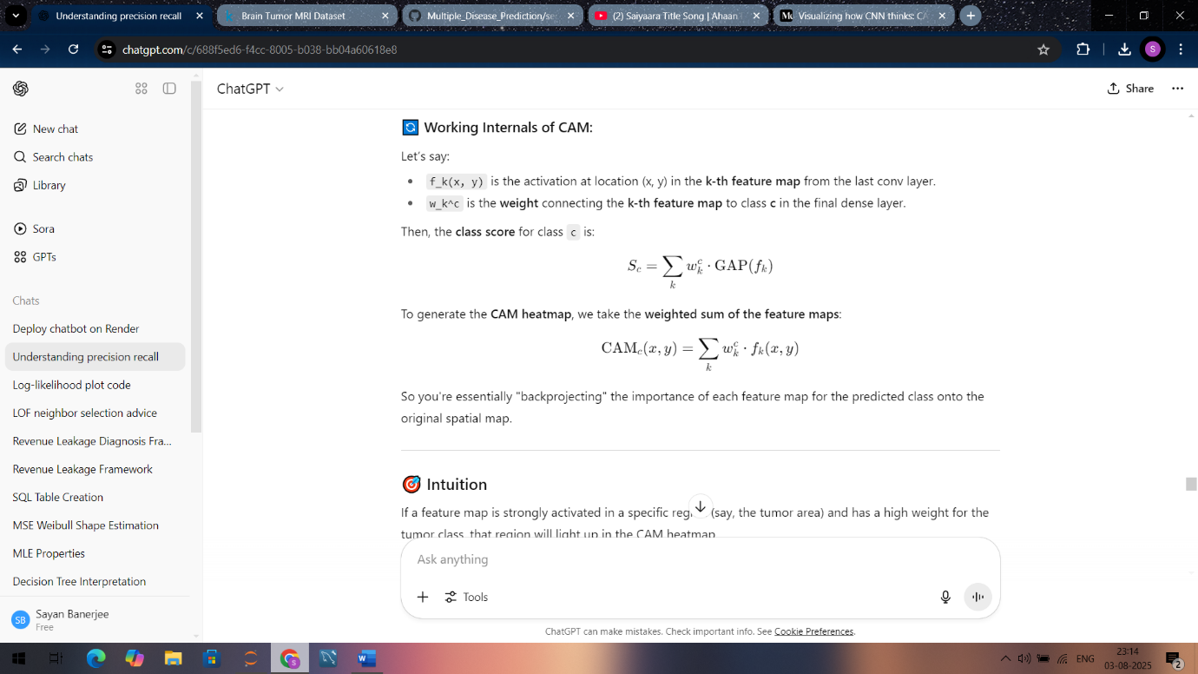

✅ Advantages of CAM
Advantage | Explanation
Interpretable | Shows "where the model is looking"
Simple | No gradient computation required
Fast | Just a forward pass — no backprop needed
Good for localization | Works well to localize tumors or lesions
Disadvantages of CAM
Limitation | Explanation
Architecture constraint | Only works with models ending in GAP + Dense — not general CNNs
No gradient awareness | Doesn’t use gradients, so less sensitive to subtle interactions
Lower resolution heatmaps | Heatmap resolution depends on last conv layer output (e.g., 7×7)
Not applicable to all models | Can’t be used directly on models with multiple dense layers or attention
One-class at a time | Heatmap is for one class only; multi-label or multi-object requires extra work

🔄 How Grad-CAM Improves on CAM
Feature | CAM | Grad-CAM
Model Restriction | Requires GAP + Dense | Works with any CNN architecture
Uses Gradients? | ❌ No | ✅ Yes (uses backprop)
Flexibility | Limited | More general
Resolution | Coarse | Better (can use intermediate layers)
Yes, CAM (Class Activation Mapping) can work for multiclass brain tumor classification, but only under specific architectural conditions.
Let’s break this down:

✅ Can CAM be used in multiclass classification?
✔️ YES — but only if:
- Your CNN ends with a Global Average Pooling (GAP) layer
- Followed by a Dense layer with softmax for classification
- Each class has a direct connection to the GAP layer output via weights

📊 Example: Brain Tumor Multiclass Setup
Suppose you have a model classifying MRI images into:
- Glioma
- Meningioma
- Pituitary
- No Tumor

Why CAM Fails in General Cases
CAM requires a specific architecture:
- Final convolution layer
- Global Average Pooling
- Dense softmax output
If your model has:
- Multiple dense layers
- No GAP
- Skip connections
👉 CAM won't work.

## Grad-Cam :-
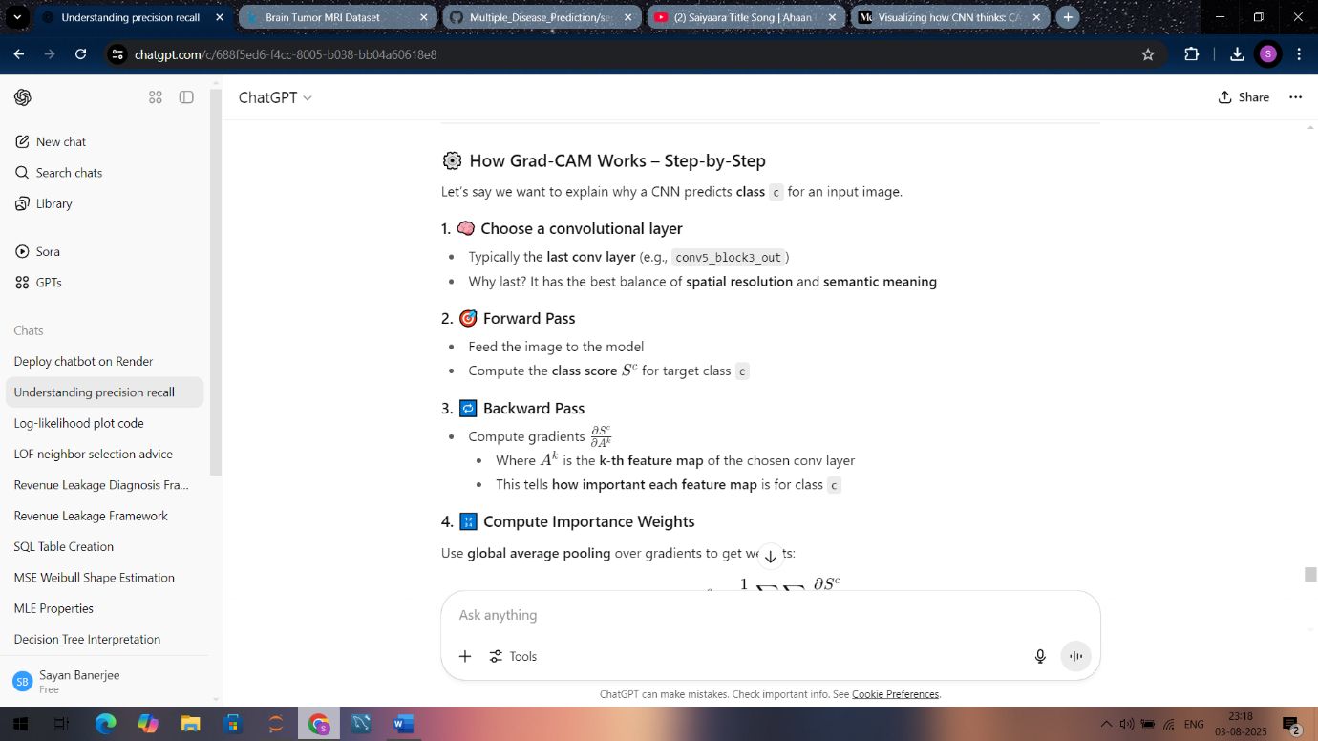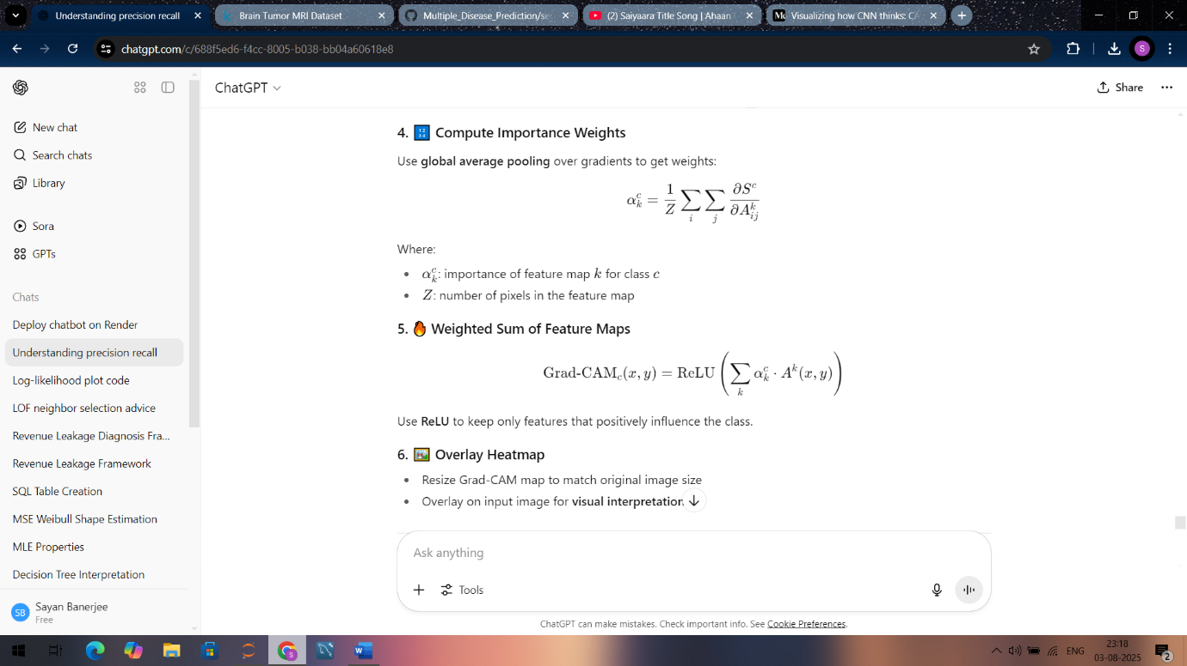
Advantages of Grad-CAM
Advantage | Description
✅ Generalizable | Works on all CNNs — even with complex structures
✅ Class-discriminative | Focuses on specific class, not generic saliency
✅ Visual explanations | Helps explain what the model is "looking at"
✅ Easy to implement | Just one forward + one backward pass

❌ Limitations of Grad-CAM
Limitation | Explanation
🔴 Low-resolution | Depends on size of last conv layer (e.g., 7×7)
🔴 Needs gradients | Requires backward pass (slower than CAM)
🔴 May highlight wrong regions | If network is overfitted or biased
🔴 Doesn’t explain non-CNN layers | Fails in transformers or tabular models
Better than GradCam:-

Grad-CAM++ — (Localized CAM)
🔧 What it improves:
- Better at identifying multiple instances of a class
- Handles smaller objects and fine-grained localization
🔬 How it works:
Instead of just averaging gradients (like Grad-CAM), it uses second-order and third-order partial derivatives to weigh activation maps more precisely.
📌 Use when:
- You have multiple tumors or multiple objects in one image
- Need more precise, fine-grained maps

🧪 2. Score-CAM — (Gradient-Free CAM)
🔧 What it improves:
- No reliance on gradients
- Works even if model gradients are noisy, unreliable, or unavailable
🔬 How it works:
- For each activation map:
  - Mask input image
  - Pass it forward through model
  - Measure the class score (logit/probability)
  - Use this score as the weight for that map
📌 Use when:
- You're using non-differentiable models (e.g., some attention-based models)
- You want gradient-free explanations

🧩 3. Ablation-CAM
🔧 What it improves:
- Offers model-agnostic interpretability
- More faithful to model behavior
🔬 How it works:
- Systematically removes (ablates) feature maps one at a time
- Measures how much the prediction drops
- Greater drop ⇒ more important feature
📌 Use when:
- You want a highly faithful, interpretable saliency method
- Gradient info is unreliable or hard to compute

📈 4. XGrad-CAM
🔧 What it improves:
- Reduces noisy saliency maps
- Emphasizes activation-weighted gradients
🔬 How it works:
- Combines Grad-CAM’s gradient info with the activation values themselves (element-wise product)
- This highlights active regions with strong influence
📌 Use when:
- You notice Grad-CAM maps are too blurry or noisy
- You want more discriminative maps

🌐 5. FullGrad
🔧 What it improves:
- Provides a global explanation of CNN decisions
- Uses both input gradients and bias gradients
🔬 How it works:
- Combines:
  - Gradient of output w.r.t input
  - Gradients from all intermediate layers
📌 Use when:
- You want a holistic explanation from both low- and high-level features
- You’re dealing with complex CNNs (e.g., ResNet, Inception)
More Questions :-
BASIC CNN INTERVIEW QUESTIONS
1. What is a Convolutional Neural Network (CNN)?
A CNN is a deep learning model designed to process data with a grid-like topology (e.g., images). It uses convolutional layers to extract spatial features and pooling layers to reduce dimensionality.

2. What is the role of filters/kernels in CNN?
Filters are small matrices that slide over the input image to detect features like edges, textures, and patterns. Each filter learns to detect a specific feature during training.

3. What is the purpose of pooling layers?
To reduce spatial dimensions of feature maps and retain important information. Common types:
- Max Pooling: Keeps the maximum value in the region.
- Average Pooling: Takes the average of the region.

4. Why do we use padding in CNN?
- Prevents shrinking of feature maps.
- Helps preserve image edges.
- Types: Valid (no padding), Same (zero padding to retain input size).

5. Why do CNNs work better than ANNs for image data?
CNNs are:
- Translation invariant (they detect features regardless of location).
- Use fewer parameters due to weight sharing.
- Better at capturing spatial hierarchy in images.

6. What is ReLU and why is it used?
ReLU (Rectified Linear Unit) = f(x) = max(0, x). It introduces non-linearity into the network and helps it learn complex patterns faster by avoiding vanishing gradients.

🔹 INTERMEDIATE CNN QUESTIONS
7. What’s the difference between Conv2D and Dense layers?
- Conv2D: Extracts features from image patches using filters.
- Dense: Fully connected layer — every neuron connected to every input feature (used toward the end for classification).

8. What is overfitting in CNN and how to prevent it?
CNNs may memorize training data and perform poorly on test data.
Solutions:
- Data augmentation
- Dropout
- Early stopping
- L2 regularization

9. What is Transfer Learning?
Using a pretrained model (e.g., ResNet, Inception) trained on a large dataset (e.g., ImageNet) and fine-tuning it for a smaller, related task.

10. What’s the role of GlobalAveragePooling2D?
Replaces the fully connected layers by averaging each feature map — reduces parameters and prevents overfitting.

11. Difference between batch normalization and dropout?
- Batch Normalization: Normalizes inputs to each layer to speed up training and improve stability.
- Dropout: Randomly drops neurons during training to prevent overfitting.

🔹 ADVANCED / PROJECT-BASED QUESTIONS
12. Explain your CNN architecture for brain tumor classification.
E.g., “I used a pretrained InceptionV3 model with frozen base layers. I added a GlobalAveragePooling layer followed by dense layers with softmax for multiclass tumor classification.”

13. How did you handle class imbalance in your tumor dataset?
- Oversampling (e.g., using ImageDataGenerator)
- Class weighting
- Focal loss (for skewed datasets)

14. How did you evaluate the performance of your model?
- Metrics: Accuracy, Precision, Recall, F1-score, AUC
- Tools: classification_report, confusion matrix, Grad-CAM for interpretability

15. What loss function did you use? Why?
For multiclass classification: categorical_crossentropy (if one-hot encoded) or sparse_categorical_crossentropy (if labels are integers).

16. How do you visualize CNN model decisions?
Using Grad-CAM, Grad-CAM++, or Score-CAM to generate attention heatmaps.

🔹 THEORY + CODING MIXED QUESTIONS
17. How do strides affect feature maps in CNN?
Increasing stride reduces feature map size (fewer overlapping windows). A stride of 1 means full coverage, stride of 2 skips every alternate pixel.

18. Explain receptive field in CNN.
The receptive field is the region of the input image that affects a particular neuron’s output. Deeper layers have larger receptive fields (more global understanding).

19. Why do we prefer small filters (3x3) in deep networks?
Stacked 3×3 convolutions:
- Give same receptive field as one large filter (e.g., 7×7)
- Introduce more non-linearities
- Reduce parameters and improve learning

20. How to tune CNN hyperparameters?
- Number of filters
- Filter size
- Learning rate
- Batch size
- Dropout rate
- Number of convolutional + dense layers
A. Conceptual CNN Questions
1. What is the difference between parameter sharing and sparse connectivity in CNNs?
- Parameter Sharing: Same filter weights used across the image.
- Sparse Connectivity: Each output neuron connects only to a local region of the input.

2. Why do we use multiple convolution layers instead of one?
Each layer captures increasingly complex patterns:
- 1st layer: edges, textures
- 2nd–3rd: shapes, contours
- Deeper: full objects, semantics

3. What is the vanishing gradient problem and how does CNN handle it?
Vanishing gradient happens in deep networks where gradients become too small to update weights.
- CNN mitigates this with ReLU and batch normalization.

4. What is stride and how does it affect output size?
- Stride = step size of the filter.
- Higher stride = smaller output size.

5. Difference between fully connected and convolutional layers.
- Fully Connected: Dense connections, ignores spatial info.
- Conv Layer: Preserves spatial locality, fewer parameters.

6. How does zero padding affect output dimensions?
- Keeps dimensions unchanged.
- Allows filters to operate on image borders.

7. Why are CNNs preferred over traditional image feature extraction methods (like SIFT, HOG)?
CNNs learn features automatically from data, adapt to task, and outperform hand-crafted features in most vision tasks.

🔷 B. Practical Implementation & Optimization
8. How did you preprocess MRI images for your tumor classification?
- Resizing to input size
- Normalization (e.g., 0–1 or mean subtraction)
- Data augmentation (rotation, zoom, flip)

9. How did you deal with overfitting in your CNN model?
Techniques:
- Data Augmentation
- Dropout
- L2 Regularization
- Early Stopping
- Using pretrained models (Transfer Learning)

10. How did you choose your CNN architecture?
Based on:
- Dataset size
- Class complexity
- Accuracy vs. speed tradeoff

11. What performance metrics did you track during training?
- Training & validation loss/accuracy
- Confusion matrix
- Precision, Recall, F1-score
- AUC (if binary/multiclass ROC)

12. What are the implications of using too many pooling layers?
- Loss of spatial information
- May hurt small object detection (like small tumors)

13. When to freeze layers in transfer learning?
- Freeze base layers initially to retain pretrained features
- Fine-tune top layers to adapt to your specific dataset

14. Difference between categorical_crossentropy and sparse_categorical_crossentropy?
- Categorical: for one-hot encoded labels
- Sparse categorical: for integer labels

🔷 C. Advanced/Research-Oriented Questions
15. Explain how Grad-CAM works and where it's useful.
(Refer to your earlier answer.)

16. What are limitations of Grad-CAM?
- Low resolution heatmaps
- May highlight large irrelevant areas
- Doesn't work well for fully-connected architectures

17. What is dilated convolution?
A convolution where filters have gaps (dilation rate > 1). It expands the receptive field without increasing filter size.

18. What are some improvements over Grad-CAM?
- Grad-CAM++: Better for multiple object classes
- Score-CAM: Doesn’t rely on gradients
- Eigen-CAM: Uses PCA of activations

19. Explain how CNN interprets spatial hierarchy.
- Shallow layers detect edges/textures
- Deeper layers combine these into shapes
- Final layers combine shapes into objects

20. Explain depthwise separable convolutions.
Used in MobileNet:
- Depthwise conv: 1 filter per input channel
- Pointwise conv: 1×1 conv to combine channels
→ Reduces parameters & computation

21. Can CNNs be used for non-image data?
Yes:
- 1D CNN for time series
- Text classification
- Sound processing
Key: the data must have spatial or temporal structure.

🔷 D. Behavioral + Project-specific
22. What was the biggest challenge in your brain tumor project?
→ Could be:
- Small dataset
- Label imbalance
- Visualizing results for doctors
- Interpreting the model (Grad-CAM)

23. How did you ensure your model is clinically reliable?
- Used Grad-CAM for interpretability
- Compared with expert-labeled regions
- Validated on external test set

24. How would you deploy your CNN model?
- Backend: Flask/FastAPI
- Frontend: React/Streamlit
- Cloud: Render/Vercel
- Use TensorFlow Lite for mobile deployment

✅ Want More?
I can simulate mock interviews, quiz you, or help you build a cheat sheet for CNNs with code snippets. Just say the word.
You said:
yes more
ChatGPT said:
Great! Let’s go deeper with more advanced, technical, and application-based CNN interview questions, especially relevant for your brain tumor classification project.

🔶 E. More Advanced CNN Questions
25. What is receptive field in CNNs? Why is it important?
- Receptive Field: Region of the input image that influences a particular output feature.
- Importance:
  - Small receptive fields → local details (edges)
  - Large receptive fields → global context (shapes)
  - Ensures deeper layers can “see” the whole object (e.g., tumor shape)

26. Why use Global Average Pooling instead of Flatten + Dense?
- GAP reduces each feature map to a single number (mean).
- Benefits:
  - Fewer parameters
  - Less prone to overfitting
  - Spatially interpretable (used in Grad-CAM)

27. What is batch normalization and how does it help?
- Normalizes layer inputs to stabilize learning.
- Helps:
  - Reduces internal covariate shift
  - Allows higher learning rates
  - Regularizes model

28. What does the convolution operation actually compute?
It computes dot product between a small filter (kernel) and a local region of the image, producing a feature map.

29. What’s the difference between training loss and validation loss trends?
- If training ↓ but validation ↑ → overfitting
- If both stay high → underfitting
- Ideal: training ↓ and validation follows similar trend

30. What does Dropout do?
- Randomly deactivates neurons during training.
- Prevents co-adaptation, encourages generalization.

🔶 F. CNN Architectures & Design
31. Name some popular CNN architectures and their improvements.
Model | Key Features
LeNet | Early architecture, basic layers
AlexNet | ReLU, Dropout, data augmentation
VGG16/19 | Deep with small (3×3) filters
ResNet | Residual connections, deep models
Inception | Parallel conv filters (1x1, 3x3)
DenseNet | Dense connections between layers
MobileNet | Lightweight, depthwise convs

32. Why are residual connections useful in ResNet?
- Prevent vanishing gradients.
- Allow gradients to flow directly through skip connections.
- Enable training of very deep networks (100+ layers)

33. What is the vanishing/exploding gradient problem?
- Vanishing: Gradients shrink → no learning
- Exploding: Gradients blow up → unstable updates
Handled by: ReLU, normalization, residuals

34. Explain the 1×1 convolution.
- Used to change number of channels.
- Also adds non-linearity & reduces computation (used in Inception).

🔶 G. Application-Based / Project Deep Dive
35. How did you evaluate your brain tumor model beyond accuracy?
- Confusion matrix
- Class-wise precision, recall, F1-score
- ROC-AUC (if applicable)
- Grad-CAM visual validation

36. How did you handle class imbalance in brain tumor types?
- Techniques:
  - Class weights in loss function
  - Oversampling (SMOTE, augment rare classes)
  - Under-sampling (cautiously)
  - Focal Loss (to focus on hard examples)

37. Can your model explain why it predicted a certain class?
Yes:
- Use Grad-CAM or Score-CAM
- Show doctors visual heatmaps of tumor regions that influenced prediction

38. How would you improve the performance of your CNN?
- Try deeper models (ResNet101, EfficientNet)
- Fine-tune more base layers
- Use learning rate schedules (e.g., ReduceLROnPlateau)
- Ensemble multiple models

39. Can you apply this CNN to other types of medical images (CT, X-ray)?
Yes, but must consider:
- Different preprocessing (e.g., windowing in CT)
- Differences in image modality (grayscale vs RGB)
- Need for domain-specific data augmentation

🔶 H. Deployment & Scaling
40. How would you deploy your model to assist doctors in real-time?
- Use Flask/FastAPI backend with trained model
- Build a React/Streamlit interface
- Host on Render/Heroku
- Optionally use TensorFlow Lite for mobile devices

41. How would you reduce model size for edge devices?
- Model quantization (8-bit, FP16)
- Use MobileNet or EfficientNet-Lite
- Prune unnecessary layers/neurons

42. What are the ethical challenges in using CNNs in medical imaging?
- Explainability (black-box problem)
- Bias in training data (e.g., underrepresented tumor types)
- Generalization across hospitals/devices
- Patient privacy when collecting image data
# Segmentation Project Questions :-
Project Questions
1. Why U-Net for segmentation?
- Designed for biomedical image segmentation.
- Combines encoder-decoder structure with skip connections to retain spatial information.
2. Explain the U-Net architecture.
- Encoder: Series of convolutional + max-pooling layers.
- Decoder: Upsampling layers using transposed convolutions.
- Skip connections: Pass features from encoder to decoder to preserve spatial resolution.
3. What is the Dice coefficient?
- Formula:
  - 2⋅TP/2TP+FP+FN
- Measures overlap between prediction and ground truth.
- Useful in imbalanced datasets.
4. What is IoU?
- Formula:
  - TP/FP+FN+TP​
- Measures intersection over union.
- Stricter than Dice.
5. Why both Dice and IoU?
- Dice is sensitive to small class imbalances.
- IoU gives conservative overlap measurement.
6. Loss function used? Why?
- Dice Loss or Dice + BCE.
- Optimizes the same metric we're evaluating.
7. Validation method?
- Train/Validation/Test split.
- Early stopping based on validation Dice.
- Visual inspection of predicted vs actual mask.

🛠️ Technical Details
8. Data augmentation used?
- Rotation, flipping, zoom, brightness, elastic deformations.
9. Overfitting prevention?
- Dropout, data augmentation, early stopping.
10. Transfer learning?
- Typically trained from scratch.
- Pre-trained backbones optional (e.g., ResNet as encoder).
11. Class imbalance handling?
- Dice loss handles imbalance.
- Could use Tversky or Focal Tversky Loss.

📊 Explainability
12. Did you use Grad-CAM or CAM?
- Grad-CAM can be used to visualize encoder attention.
- Not directly on segmentation output, but on features.
13. How to visualize results?
- Overlay mask on MRI.
- Contour plots showing predicted vs ground truth boundary.

🚀 Deployment
14. Deployment plan?
- Dockerize model.
- Serve via FastAPI.
- Deploy to cloud or local hospital server.
- Integrate with existing PACS system.

⚡ Advanced / Follow-up Questions
15. Improvements over U-Net?
- Attention U-Net (focus on relevant regions).
- U-Net++ (nested skip connections).
16. Semantic vs instance segmentation?
- Semantic: Classify each pixel.
- Instance: Also separate objects of same class.
17. Handling 3D MRI?
- Use 3D U-Net.
- Or apply 2D U-Net slice-by-slice and aggregate.
18. Post-processing?
- Morphological operations (remove small blobs).
- Conditional random fields (CRFs).

🧐 Behavioral Add-ons
19. What challenges did you face?
- Class imbalance.
- Varying tumor shapes.
- Limited data.
20. How would you extend this project?
- Try ensemble of U-Net + DeepLab.
- Use BraTS dataset full scale.
- Add tumor classification post segmentation.
21. How does receptive field impact segmentation performance?
- Larger receptive fields capture more context but risk losing fine detail.
- U-Net balances local and global features via skip connections.
22. How would your model generalize to different MRI modalities (e.g., FLAIR, T1, T2)?
- Requires normalization across modalities.
- Might need domain adaptation or modality-specific training.
23. How to handle overlapping tumors in segmentation?
- Use multi-label segmentation instead of single-class prediction.
- Consider instance segmentation models like Mask R-CNN.
24. How would you optimize inference time for deployment?
- Convert to ONNX or TensorRT.
- Quantize or prune the model.
- Use tiling strategy for high-resolution MRI scans.
25. How do skip connections improve gradient flow and model performance?
- Enable the decoder to reuse spatial details from encoder.
- Mitigate vanishing gradient by providing shortcuts.
26. What would happen if you removed skip connections in U-Net?
- Segmentation masks would be coarse and lack boundary precision.
- Model would lose local detail.
27. How to evaluate uncertainty in segmentation predictions?
- Monte Carlo dropout for stochastic predictions.
- Use entropy or variance maps across multiple forward passes.
28. Can segmentation be used for tumor volume estimation?
- Yes, by summing voxel volumes from predicted masks across slices.
- Helps in tracking tumor progression.
29. How would you build an active learning pipeline for tumor segmentation?
- Use uncertainty sampling to pick ambiguous cases.
- Ask human expert to annotate.
- Retrain model on updated data.
30. What role does resolution play in segmentation accuracy?
- Higher resolution improves detail but increases memory cost.
- Trade-off between accuracy and compute.
- 1. How would you modify your CNN model to handle very small tumors that occupy few pixels?
- Use higher-resolution inputs, add attention mechanisms, or modify loss functions (e.g., Focal Loss or Tversky Loss).
- 2. How would you train a CNN if MRI scans have different resolutions or slice thicknesses?
- Normalize input sizes via resampling, and augment with scaling. Use 3D CNNs if the third dimension is important.
- 3. What challenges arise when using CNNs on medical images versus natural images?
- Class imbalance, lack of labeled data, higher noise, domain specificity, modality variation (e.g., T1, T2), and ethical concerns.
- 4. How can CNNs be made explainable for clinical decision support?
- Use Grad-CAM, saliency maps, attention visualization, and model calibration. Generate confidence intervals.
- 5. Suppose your CNN predicts a tumor where none exists (false positive). How would you address it?
- Increase negative samples, use post-processing (e.g., remove small noisy predictions), or adjust decision thresholds.
- 6. Can you use CNNs to detect the type of tumor from the segmented region?
- Yes. Use a two-stage pipeline: segmentation with CNN/U-Net followed by patch-based classification CNN on segmented ROI.

- 🧬 Application-Based Segmentation Questions
- 7. What happens if segmentation masks are noisy or partially labeled?
- Use weakly supervised methods, noisy label correction techniques, or semi-supervised learning with pseudo-labels.
- 8. How would you segment multiple types of tumors in the same image (e.g., multiclass segmentation)?
- Use a softmax output with one-hot encoded masks. Each class gets a channel in the final output.
- 9. How can segmentation help radiologists beyond detection?
- Quantify tumor volume, monitor growth over time, assist in surgical planning or treatment targeting.
- 10. How to improve segmentation in highly imbalanced class cases?
- Try Tversky loss, Focal Tversky loss, use oversampling of minority regions, or crop regions around suspected tumors.
- 11. What if your model segments background as tumor in noisy MRI scans?
- Introduce more background variation in training, use hard example mining, or integrate denoising autoencoders.
- 12. How would you handle segmenting tumors across time-series MRI scans?
- Use 3D U-Net with temporal features, or CNN + RNN hybrid models that track temporal consistency.

- ⚙️ Bonus: Deployment-Ready Thinking
- 13. How would you integrate a tumor segmentation system in a hospital PACS system?
- Expose it as a DICOM-compatible inference API using libraries like pydicom, wrapped with FastAPI, and containerized via Docker.
- 14. What regulatory or ethical concerns might arise when deploying segmentation models in healthcare?
- Model explainability, bias in training data, lack of robustness across scanners/hospitals, need for FDA/CE certification.

Read the architecturs(resnet,mobilenet,inceptionnet,unet,densenet,alexnet) and basics like dropouts , batchnorm etc from ANN and CNN notes . read segmentation in detail

